|  |  |
| --- | --- |
| Report ID | Rpt002 |
| Title | Top Listing Dashboard for Customer, Manufacturer, Product by Sales and Quotation |
| Document Version | 1.0 |

**Design Layout:**

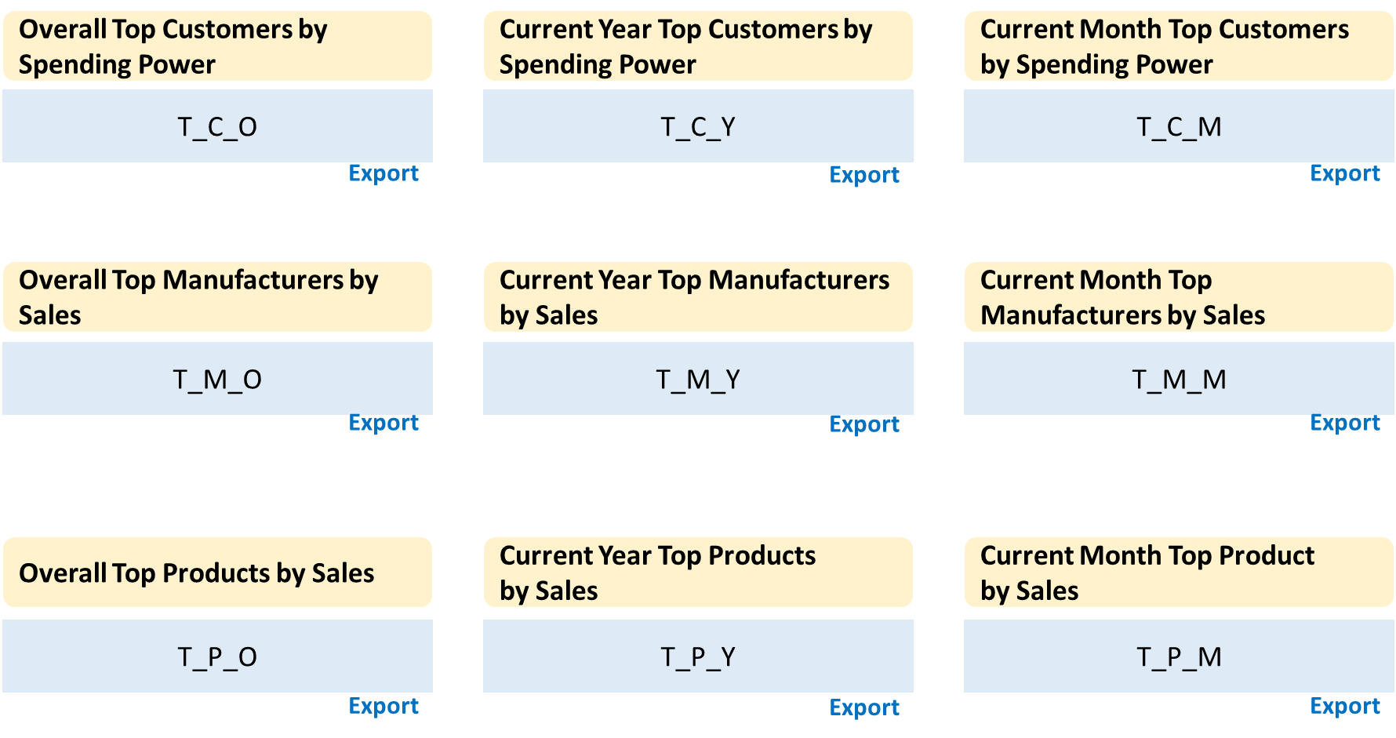

|  |  |
| --- | --- |
| **Display Area** | T_C_O |
| **Output** | Top <***tco_conf_disp_list>*** customer list, Email ID or First + Last name, with the spending values, for the entire sale records.  ** Export to output records in excel file for download. |
| **Value Display Description** | If record don’t have Email_ID, then display the First + Last name.  Each customer display with the spending value, in RM. |
| **Business Logic** | Select **Email_ID**, **Firstname**, **Lastname**, **Spent** from **toplist_dashboard** where **list_type**=’**tco**’ limit *<****tco_conf_disp_list****>* order by **Spent**  ** Use limit *<****tco_conf_export_list****>* for export function |
| **DB / Tables** | toplist_dashboard |
| **Page Load Calc. / Pre-Calculate** | Pre-Calculate |

|  |  |
| --- | --- |
| **Display Area** | T_C_Y |
| **Output** | Top <***tcy_conf_disp_list>*** customer list, Email ID or First + Last name, with the spending values, for the entire sale records for <***current year***>  ** Export to output records in excel file for download. |
| **Value Display Description** | If record don’t have Email_ID, then display the First + Last name.  Each customer display with the spending value, in RM. |
| **Business Logic** | Select **Email_ID**, **Firstname**, **Lastname**, **Spent** from **toplist_dashboard** where **list_type**=’**tcy**’ limit *<****tcy_conf_disp_list****>* order by **Spent**  ** Use limit *<****tcy_conf_export_list****>* for export function |
| **DB / Tables** | toplist_dashboard |
| **Page Load Calc. / Pre-Calculate** | Pre-Calculate |

|  |  |
| --- | --- |
| **Display Area** | T_C_M |
| **Output** | Top <***tcm_conf_disp_list>*** customer list, Email ID or First + Last name, with the spending values, for the entire sale records for <***current month***>  ** Export to output records in excel file for download. |
| **Value Display Description** | If record don’t have Email_ID, then display the First + Last name.  Each customer display with the spending value, in RM. |
| **Business Logic** | Select **Email_ID**, **Firstname**, **Lastname**, **Spent** from **toplist_dashboard** where **list_type**=’**tcm**’ limit *<****tcm_conf_disp_list****>* order by **Spent**  ** Use limit *<****tcm_conf_export_list****>* for export function |
| **DB / Tables** | toplist_dashboard |
| **Page Load Calc. / Pre-Calculate** | Pre-Calculate |

|  |  |
| --- | --- |
| **Display Area** | T_M_O |
| **Output** |  |
| **Value Display Description** |  |
| **Business Logic** |  |
| **DB / Tables** |  |
| **Page Load Calc. / Pre-Calculate** |  |

|  |  |
| --- | --- |
| **Display Area** | T_M_Y |
| **Output** |  |
| **Value Display Description** |  |
| **Business Logic** |  |
| **DB / Tables** |  |
| **Page Load Calc. / Pre-Calculate** |  |

|  |  |
| --- | --- |
| **Display Area** | T_M_M |
| **Output** |  |
| **Value Display Description** |  |
| **Business Logic** |  |
| **DB / Tables** |  |
| **Page Load Calc. / Pre-Calculate** |  |

|  |  |
| --- | --- |
| **Display Area** | T_P_O |
| **Output** |  |
| **Value Display Description** |  |
| **Business Logic** |  |
| **DB / Tables** |  |
| **Page Load Calc. / Pre-Calculate** |  |

|  |  |
| --- | --- |
| **Display Area** | T_P_Y |
| **Output** |  |
| **Value Display Description** |  |
| **Business Logic** |  |
| **DB / Tables** |  |
| **Page Load Calc. / Pre-Calculate** |  |

|  |  |
| --- | --- |
| **Display Area** | T_P_M |
| **Output** |  |
| **Value Display Description** |  |
| **Business Logic** |  |
| **DB / Tables** |  |
| **Page Load Calc. / Pre-Calculate** |  |

**Pre-Calculate Top-Listing Tables Design**

|  |  |  |
| --- | --- | --- |
| **Table Name** | toplist_cust_dashb | |
| **Column** | **Type** | **Description** |
| Id | INT | Auto increment id |
| email_id | VARCHAR 300 | Store customer email address |
| firstname | VARCHAR 200 | Store customer firstname |
| lastname | VARCHAR 200 | Store customer lastname |
| tel | VARCHAR 100 | Store customer telephone number |
| spent | DECIMAL(15,4) | Store the customer total spending value |
| top_list_type | VARCHAR 50 | Store the type of top list. Pre-defined key to indicate the records. |

**Pre-Calculate Tables Data Supply**

* *Purge whole table for every cycle of reload.*
* *All fields will be storing with duplicate values, just the loading condition different with display cases, stored in* ***top_list_type*** *field.*

|  |  |  |
| --- | --- | --- |
| **Table Name** | toplist_cust_dashb | |
| **Column** | **Type** | **Business Logic to supply value** |
| email_id  firstname  lastname  tel | VARCHAR 300  VARCHAR 200  VARCHAR 200  VARCHAR 100 | select email_id, firstname, lastname, tel, sum(product_total) as spent, <hardcoded_top_list_type> as top_list_type from extract_orders  where <*condition depend on top list type*> group by tel limit to <*record number from* *configuration_table*> |
| spent  top_list_type | DECIMAL(15,4)  VARCHAR 50 | select email_id, firstname, lastname, tel, sum(product_total) as spent, ‘***tco***’ as top_list_type group by tel limit to *<****tco_conf_export_list****>* |
| spent  top_list_type | DECIMAL(15,4)  VARCHAR 50 | select email_id, firstname, lastname, tel, sum(product_total) as spent, ‘***tcy***’ as top_list_type from extract_orders where *year=****<current year>*** group by tel limit to *<****tcy_conf_export_list****>* |
| spent  top_list_type | DECIMAL(15,4)  VARCHAR 50 | select email_id, firstname, lastname, tel, sum(product_total) as spent, ‘***tcm***’ as top_list_type from extract_orders where *year=****2017*** and month=<***current month***> group by tel limit to *<****tcm_conf_export_list****>* |

**Configuration Table Design (Refer to [Rpt001][V1.0]-RptReq-Dashboard)**

* Configured Data for ***conf_dashboard*** used for top-listing dashboard.

|  |  |  |  |
| --- | --- | --- | --- |
| **ID** | **CONF_NAME** | **CONF_VALUE** | **CONF_INDEX** |
| 10 | ***tco_conf_disp_list*** | 10 | 0 |
| 11 | ***tco_conf_export_list*** | 1000 | 0 |
| 12 | ***tcy_conf_disp_list*** | 10 | 0 |
| 13 | ***tcy_conf_export_list*** | 1000 | 0 |
| 14 | ***tcm_conf_disp_list*** | 10 | 0 |
| 15 | ***tcm_conf_export_list*** | 1000 | 0 |